p ⇒ q = ¬p ᵥq q ⇒ p(converse) ¬p ⇒ ¬q(inverse) ¬q ⇒ ¬p(contrapositive)
I_{f} : PROP → {T , F }, valid – tautology, satisfiable – consistent, unsatisfiable – contradictory
Modus ponens: p, p ⇒ q – q | Modus tollens: ¬q, p ⇒ q – ¬p | Hyp. Syll.: p ⇒ q, q ⇒ r – p ⇒ r
Disj. Syll.: p ᵥ q, ¬p – q | Addition: p - p ᵥ q | Simplification: p ᶺ q – p | Resolution: p ᵥ q, ¬p ᵥ r - q ᵥ r
---------------------------------------------------------------------------------------------------------------------------------------
a = mb + r –- [a+b] mod c = [[a mod c] + [b mod c]] mod c --- [ab] mod c = [a mod c][b mod c] mod c
b|a → b divides a --- (a,b) = gcd --- (a,b) = 1 → coprime
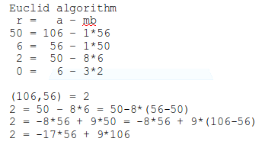
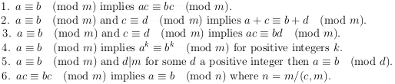

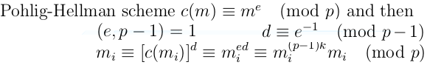

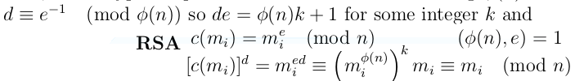
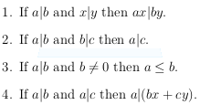
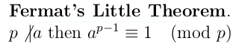

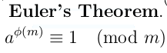

---------------------------------------------------------------------------
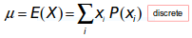
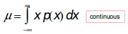
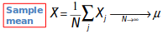
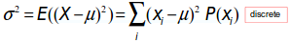
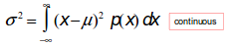
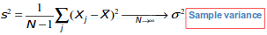
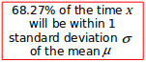

---------------------------------------------------------------------------
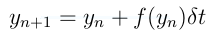
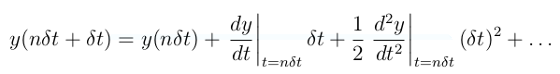
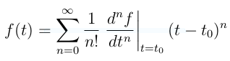
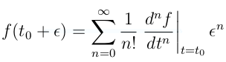
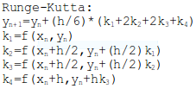
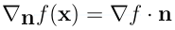
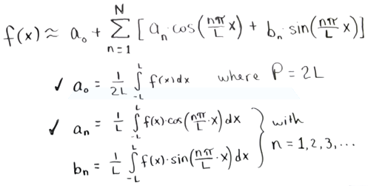
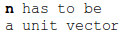
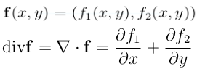
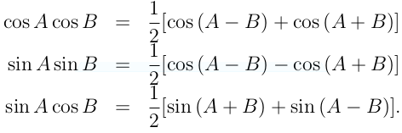

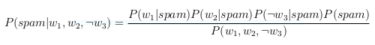

---------------------------------------------------------------------------
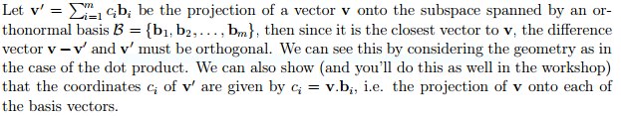

Rank(A)=# of pivots
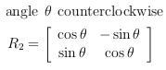
of A in echelon form
